H.T No
Regulations:
A19

Sreenidhi Institute of Science and Technology
(An Autonomous Institution)
Code No: 7M214 Date: 29-Oct-2021 (FN)

M.Tech I-Year II-Semester External Examination, Oct/Nov - 2021 (Regular & Supplementary)
ADVANCED FINITE ELEMENT ANALYSIS(TE)

Time: 3 Hours Max.Marks:70

Note: a) No additional answer sheets will be provided.
b) All sub-parts of a question must be answered at one place only, otherwise it will not be valued.
c) Missing data can be assumed suitably.

ANSWER ANY 5 OUT OF 8 QUESTIONS. EACH QUESTION CARRIES 14 MARKS.

Bloom's Cognitive Levels of Learning (BCLL)
Remember | L1 | Apply | L3 | Evaluate | L5
Understand | L2 | Analyze | L4 | Create | L6

 |  |  | BCLL | CO(s) | Marks
1. |  | Determine the displacements of node 1 and node 2 in the spring system shown in Fig. 1. Use minimum potential energy principle to assemble equations of equilibrium.  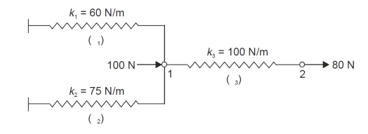 Fig. 1 | L5 | CO1 | [14M]
2. |  | A beam of uniform rectangular cross section with width 1 cm and depth 2 cm and length 60 cm is subjected to a vertical concentrated load of 1000 N as shown in Fig: 2. If the beam is fixed at both ends. Develop the Global stiffness matrix (K). Take E = 10⁷ N/cm²  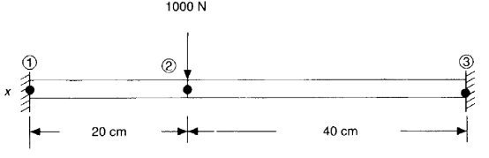 Fig: 2 | L4 | CO2 | [14M]
3. |  | Calculate the deflection at the point of load application using one –element model for the configuration shown in Fig: 3  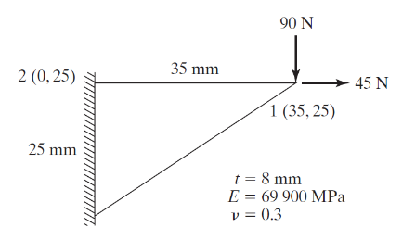Fig: 3 | L3 | CO3 | [14M]
4. |  | Consider a rectangular element as shown in Fig: 4. Assume plane stress condition, E = 30 x 10⁶ psi, ϑ = 0.3 and q = [0, 0, 0.002, 0.003, 0.006, 0.0032, 0, 0]^{T} in. Assess Jacobian Matrix and element strain displacement matrix [B].  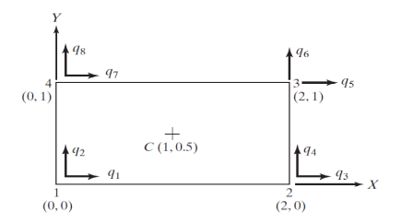 Fig: 4 | L5 | CO4 | [14M]
5. |  | A composite wall consists of three materials, as shown in Fig: 5. The outer temperature is T₀ = 20⁰C. Convective heat transfer takes place on the inner surface of the wall with T∞ = 800⁰C and h = 25 W/m² ⁰C.  Determine the temperature distribution in the wall.  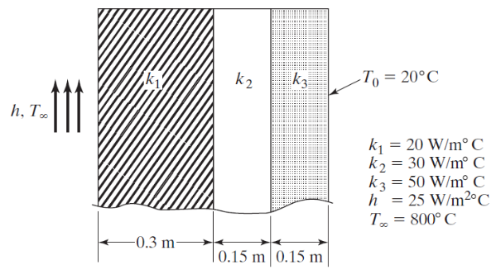 Fig: 5 | L5 | CO5 | [14M]
6. | a) | Develop the element mass matrix for Truss element. | L4 | CO6 | [7M]
 | b) | Determine the Eigen values for the stepped bar shown in Fig: 6  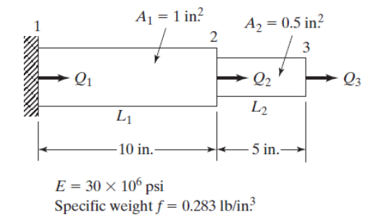 Fig: 6 | L5 | CO6 | [7M]
7. | a) | Define the following terms with suitable examples:  - Plane stress, Plane strain  - Node, Element |  | CO1 | [5M]
 | b) | Explain the quadratic shape functions of a bar element. | L2 | CO2 | [5M]
 | c) | Compute the shape functions N₁, N₂ and N₃ at the interior point P for the triangular element shown in Fig: 7  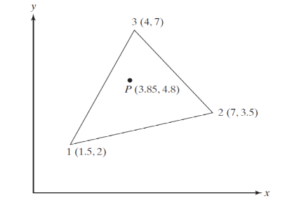 Fig: 7 | L3 | CO3 | [4M]
8. | a) | Apply Gaussian Quadrature to obtain an exact value of the integral.  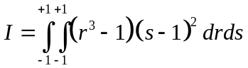 | L3 | CO4 | [5M]
 | b) | Discuss the Iso-parametic element and Axisymmetric analysis. | L2 | CO5 | [5M]
 | c) | Explain the Lumped Mass matrix | L2 | CO6 | [4M]

-- 00 -- 00 –

